

Project Demo Planning

Date | 15 March 2026
Team ID | NEHAL YADAV
Project Name | FORMULA 1 Race Intelligence Dashboard Analysis Report 2010-2026
Maximum Marks | 1 Mark

Project Demo Planning:
A well-structured demo plan ensures that the team presents the project effectively, covering all key aspects in a clear and organized manner. This document outlines the plan for demonstrating the project, including the flow of the demo, key features to highlight, and responsibilities of each team member.

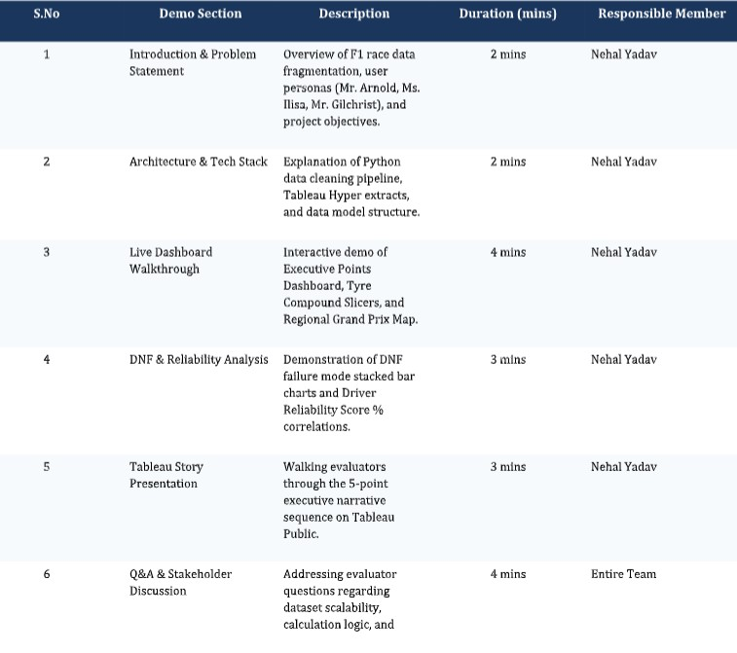

Demo Flow Summary:

